Vina ina gnd pulse(0 0 1n 1n 1n 5n 15n)

Vinb inb gnd pulse(0 0 1n 1n 1n 5n 15n)

Vinc inc gnd pulse(0 1.8 1n 1n 1n 5n 15n)

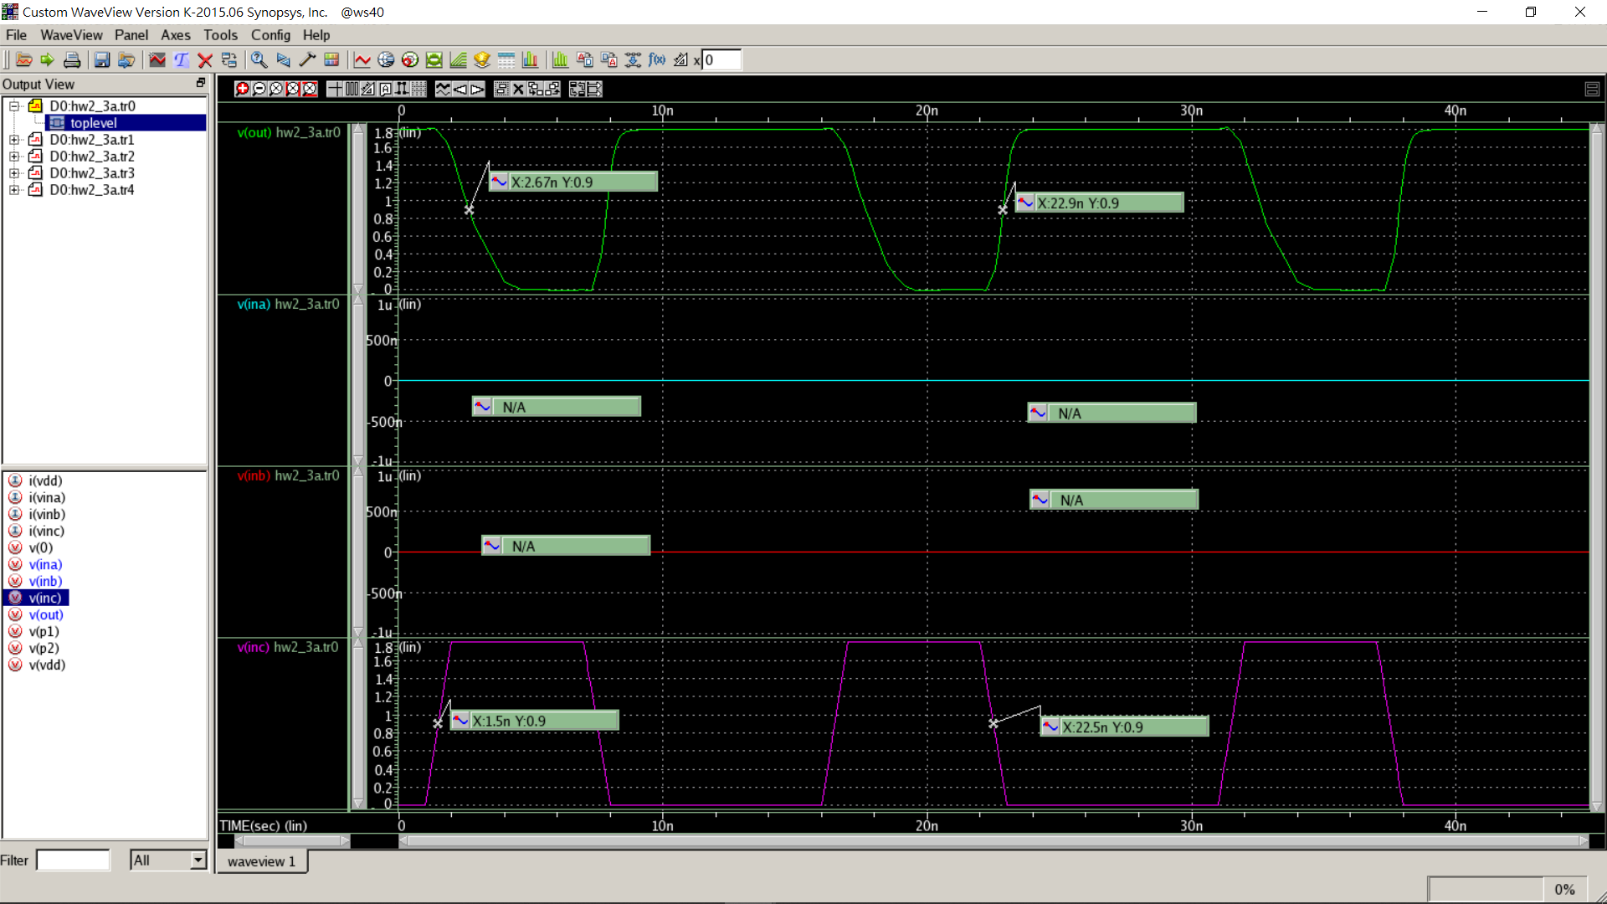

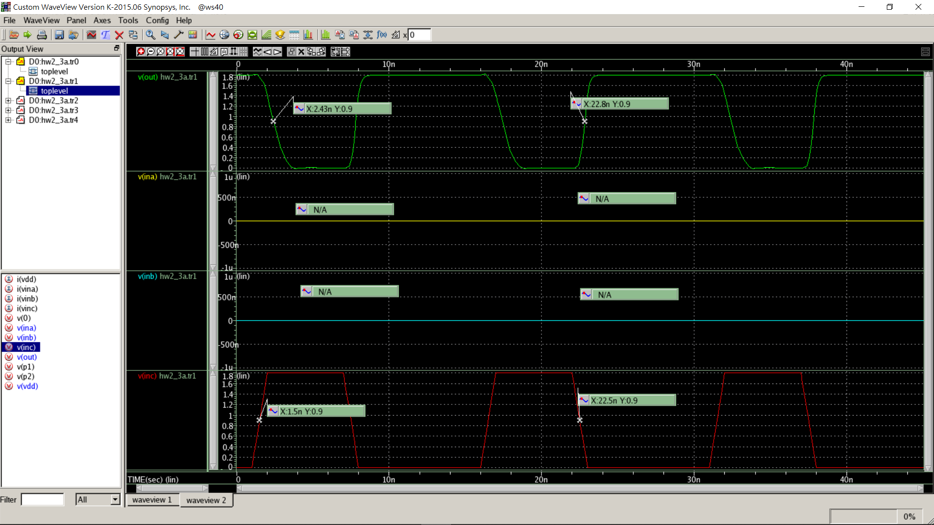

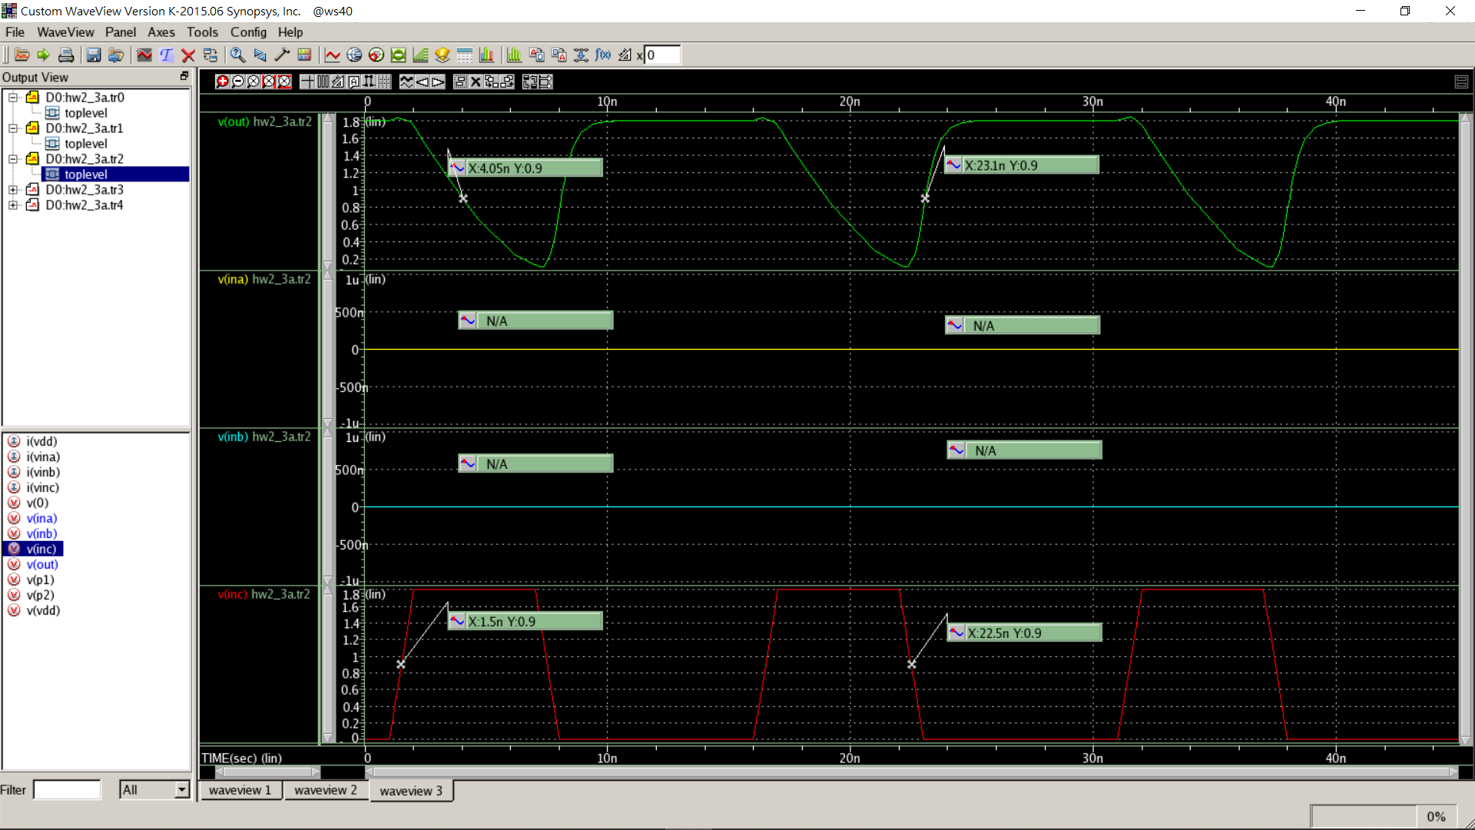

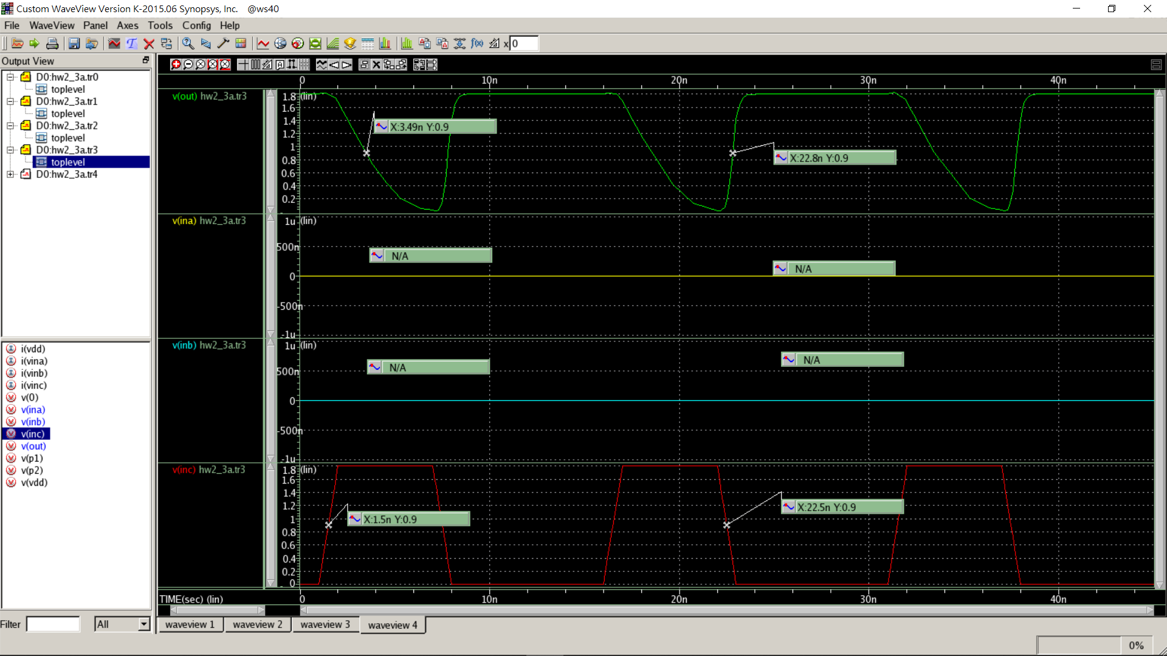

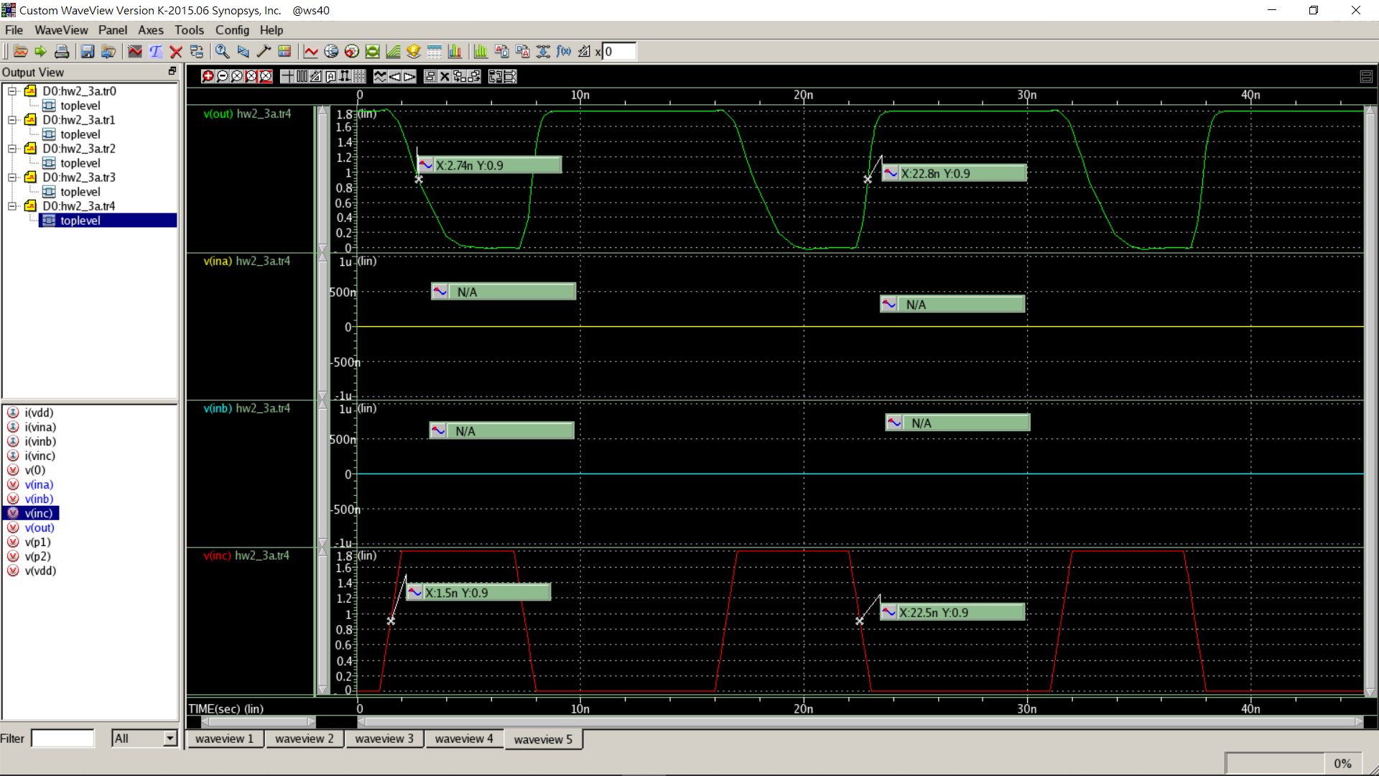

Vina ina gnd pulse(0 0 1n 1n 1n 5n 15n)

Vinb inb gnd pulse(0 1.8 1n 1n 1n 5n 15n)

Vinc inc gnd pulse(0 0 1n 1n 1n 5n 15n)

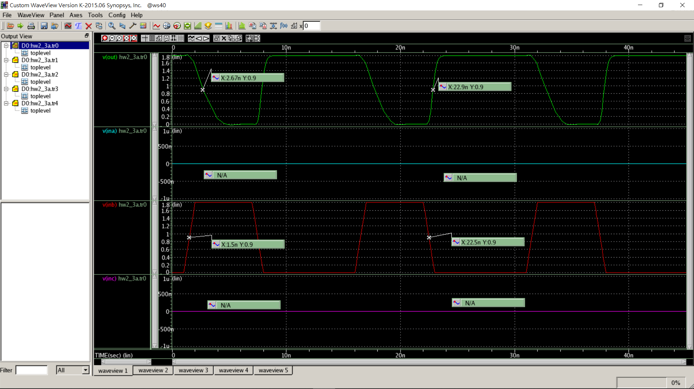

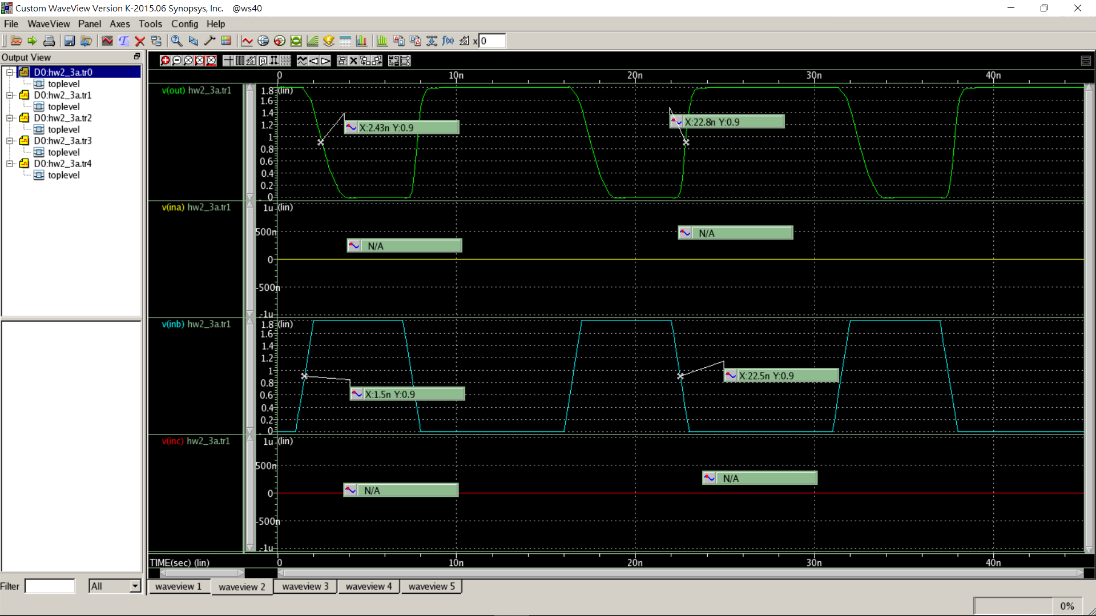

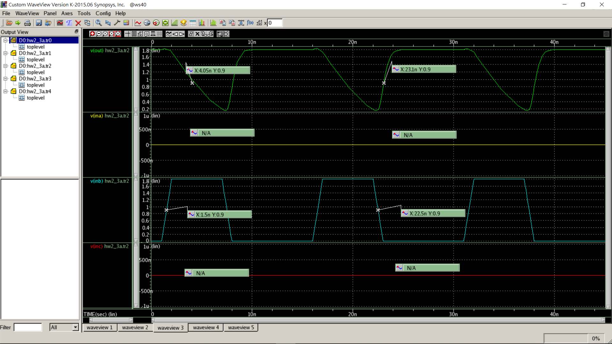

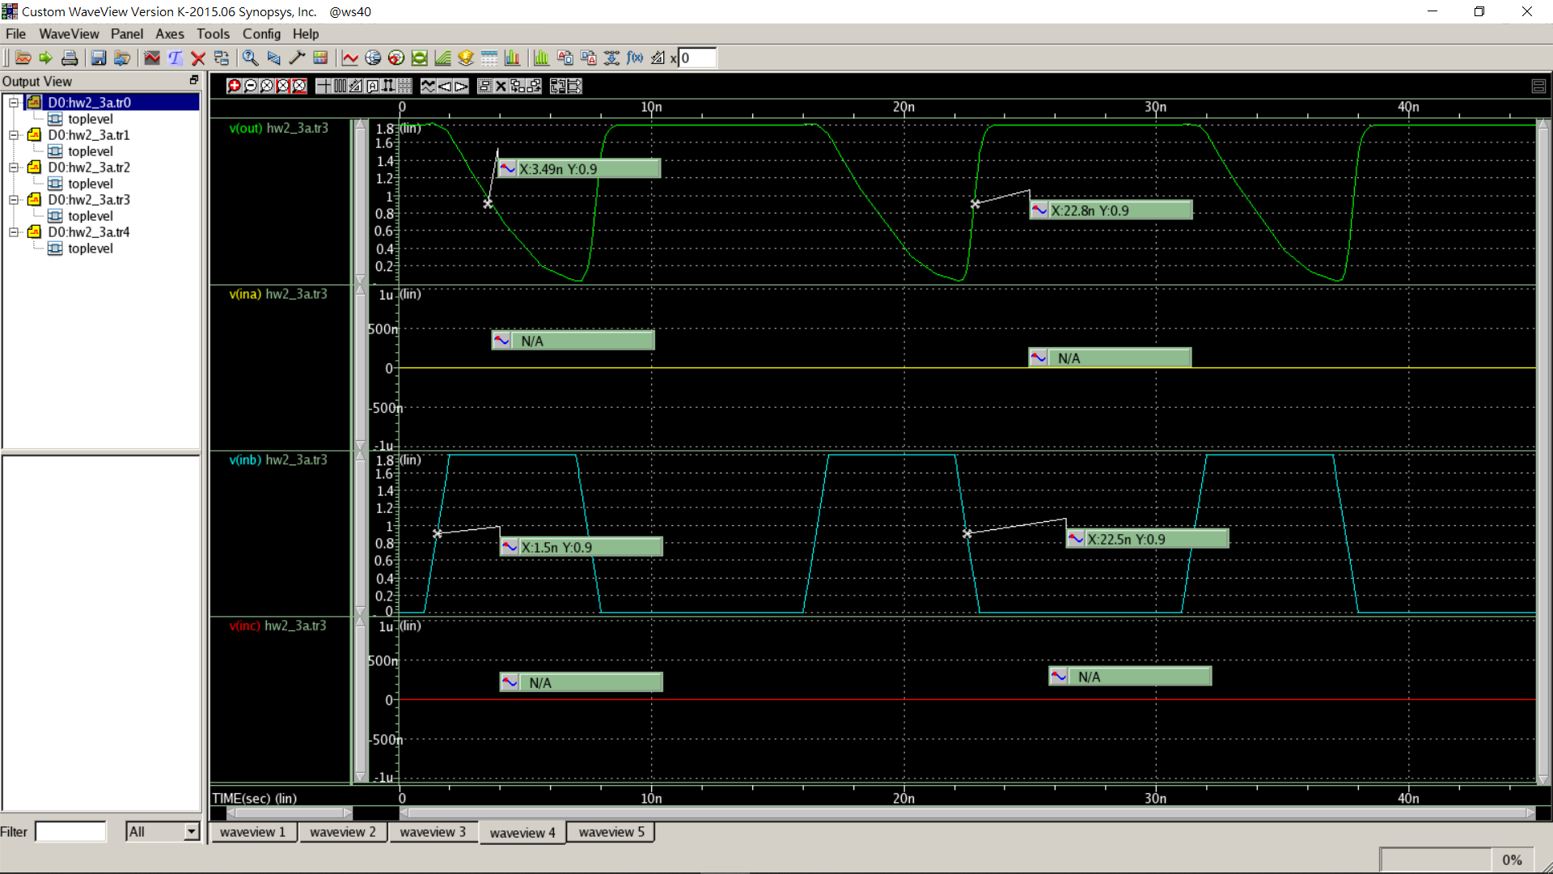

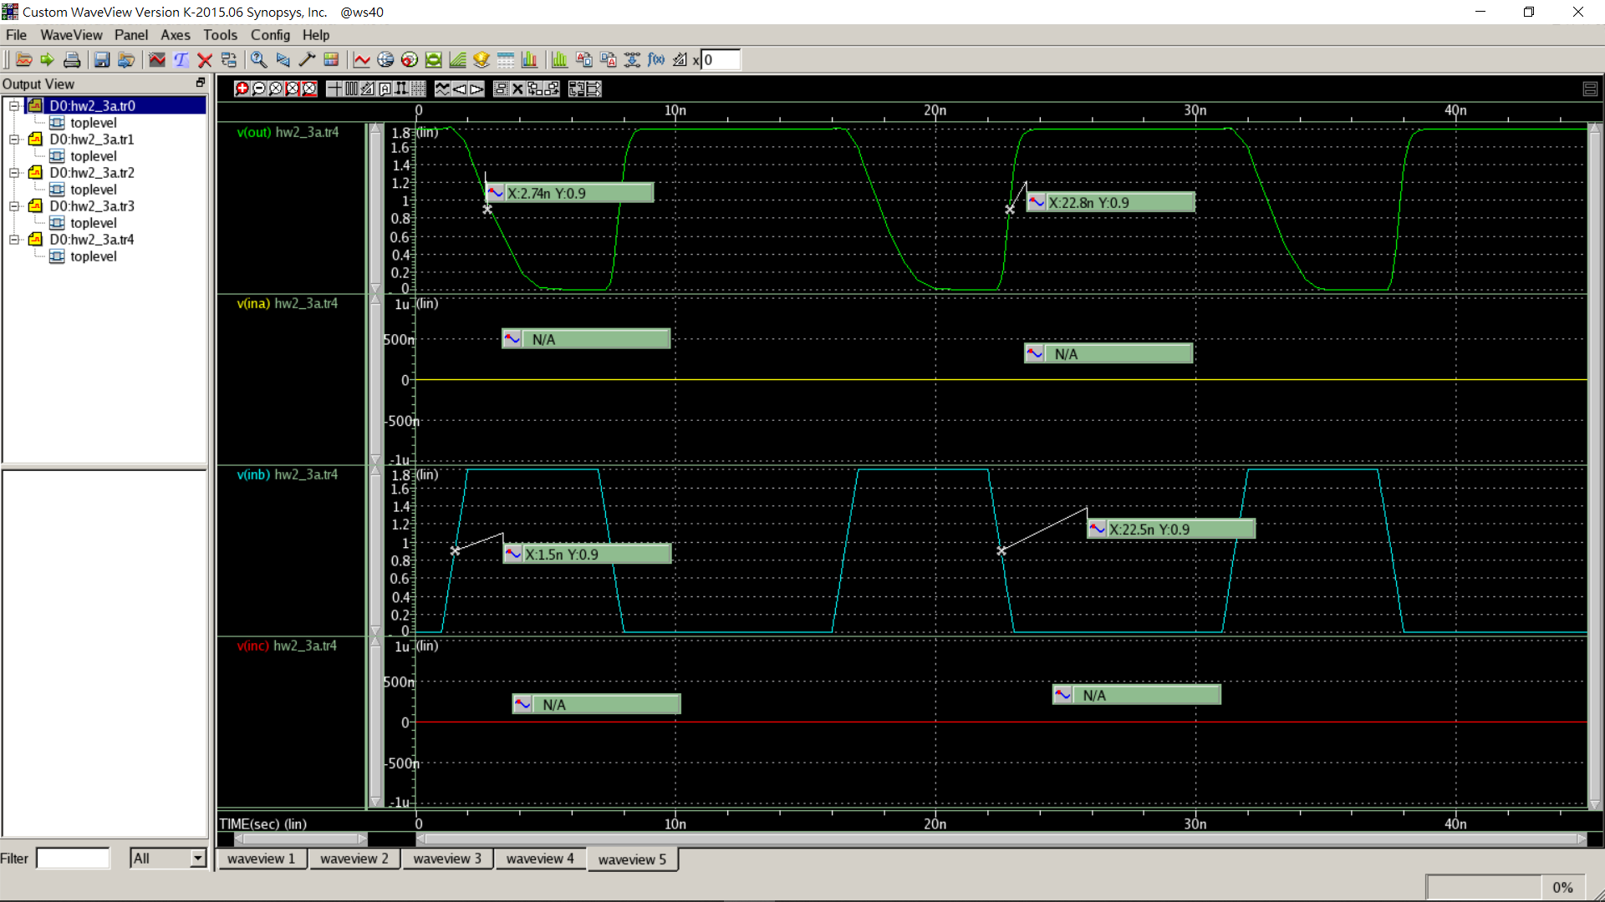

Vina ina gnd pulse(0 1.8 1n 1n 1n 5n 15n)

Vinb inb gnd pulse(0 0 1n 1n 1n 5n 15n)

Vinc inc gnd pulse(0 0 1n 1n 1n 5n 15n)

